Tutorial 2

1. **Explain the concept of event-driven programming.**

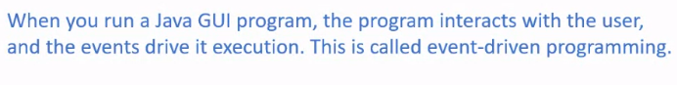

1. **Describe events, event sources, and event classes.**

**Events**

A type of signal to the program that something has happened.

**Event sources**

The GUI component on which an event is fired or generated

**Event classes**

Event class has an instance which is event and the root of the event class is *java.util.EventObject*

Sample Answer:

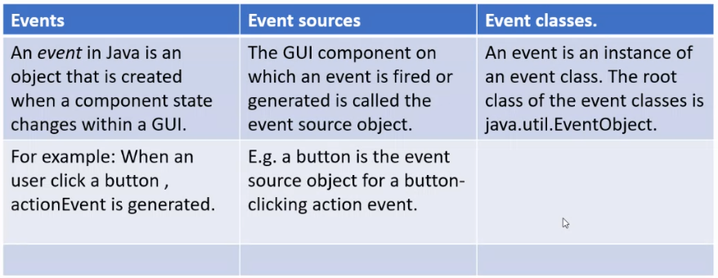

1. **Describe and Write code to handle events by creating listeners using inner classes and anonymous inner classes.**

**Inner Class**

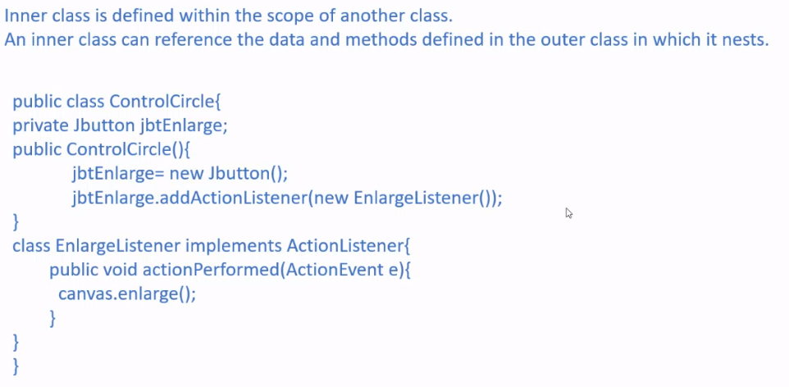

**Anonymous inner classes**

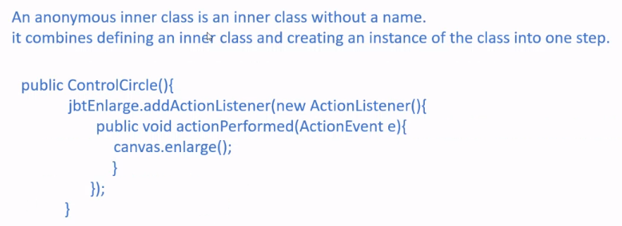

1. **Describe how to Register listener objects in the source object**

* Create a listener object of the corresponding listener interface
* The listener object will be registered with the event source object using the method *source.addActionListener(listener)*
* Example:

| JButton jbt = new JButton("OK");  ActionListener listener = new OKListener();  jbt.addActionListener(listener); |
| --- |

Sample Answer:

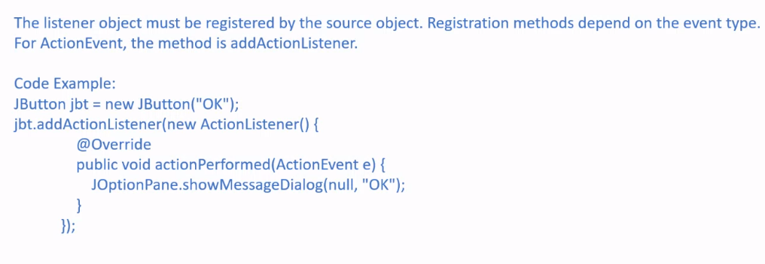

1. **Describe how an event is handled**

